**Task No. 1:** Write a program which uses Iterative Binary Search algorithm to search age of the person using his/her name.

**Solution:**

static int SearchAge(String[,] array, string name)

{

int lb = 0;

int ub = array.GetLength(0) - 1;

while (lb < ub)

{

int mid = (lb + ub) / 2;

int value = name.CompareTo(array[mid, 0]);

if (value == 0)

return mid;

if (value > 0)

lb = mid + 1;

else ub = mid - 1;

}

return -1;

}

static void Main(string[] args)

{

string[,] array = { { "Zaran", "16" }, { "Altamish", "20" }, { "Usama", "19" }, { "Hassan", "22" }, { "Zohaib", "37" } };

Console.WriteLine("Names of Person:");

for (int i = 0; i < array.GetLength(0); i++)

Console.WriteLine(i + 1 + ". " + array[i, 0]);

Console.WriteLine("Enter any name from above to find the age of person:");

string name = Console.ReadLine();

int index = SearchAge(array, name);

if (index != -1)

{

Console.WriteLine("Age of {0} = {1}", array[index, 0], array[index, 1]);

}

else

{

Console.WriteLine("No Recoed found");

}

}

}

}

**Output:**

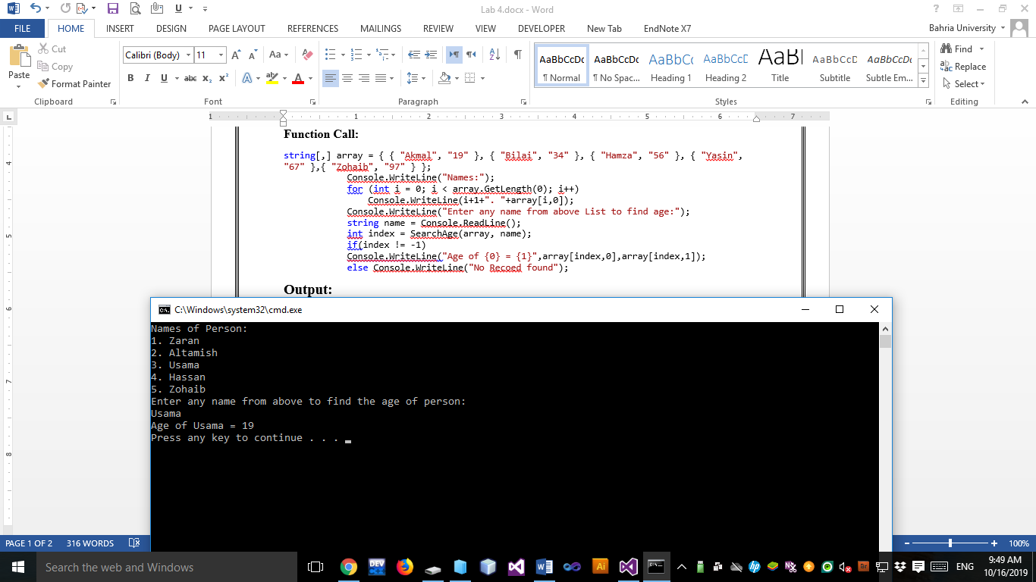

**Task No. 2:** Write a program which uses Recursive Binary Search algorithm to search the elements 35, and 78 and delete it.

NUMBERS = [7, 12, 33, 35, 49, 56, 57, 60, 74, 98]

**Solution:**

static void DeleteValue(int[] array, int value1, int value2)

{

int[] index = new int[2];

index[0] = RecursiveBinarySearch(array, 0, array.Length - 1, value1);

index[1] = RecursiveBinarySearch(array, 0, array.Length - 1, value1);

for (int i = 0; i < index.Length; i++)

{

for (int k = index[i]; k < array.Length - 1; k++)

{

array[k] = array[k + 1];

array[k + 1] = 0; }

} }

static int RecursiveBinarySearch(int[] array , int lb, int ub,int value)

{

int mid = (lb + ub) / 2;

if (array[mid] == value)

return mid;

if (lb<ub)

{

if (array[mid] > value)

return RecursiveBinarySearch(array, lb, mid-1, value);

return RecursiveBinarySearch(array, mid+1, ub, value); }

Console.WriteLine(value+" Not Found!");

return -1;

}

Function Call:

int[] array = { 7, 12, 33, 35, 49, 56, 57, 60, 74, 98 };

Console.WriteLine("Array Before Deleting Values...\n");

DisplayArray(array);

DeleteValue(array, 35, 78);

Console.WriteLine("\nArray after Deleting Values...\n");

DisplayArray(array);

**Output:**

